Task 1: Common BIOS/POST Errors

BIOS/POST Error Message | Hardware or Configuration Issue
CMOS Checksum Error – Defaults Loaded | CMOS battery is weak or BIOS settings have been reset.
Keyboard Error | Present Keyboard is not connected or is faulty.
No Boot Device Found | Hard disk/SSD is not detected or has no operating system installed.
CPU Fan Error | CPU cooling fan is not connected or has failed.
Memory Error / RAM Failure | RAM is loose, faulty, or not detected by the motherboard.

Task 2: Three Repeating Beeps – AMI BIOS
For AMI BIOS, 3 short beeps usually indicate a RAM (Memory) failure. This means the system cannot properly detect or use the installed memory.
Troubleshooting steps:
- Turn off the PC, reseat the RAM stick(s), and try booting again.
- If it still beeps, try booting with just one RAM stick at a time to find out if one stick is faulty.

Task 3: Access BIOS/UEFI

BIOS SETUP PAGE:
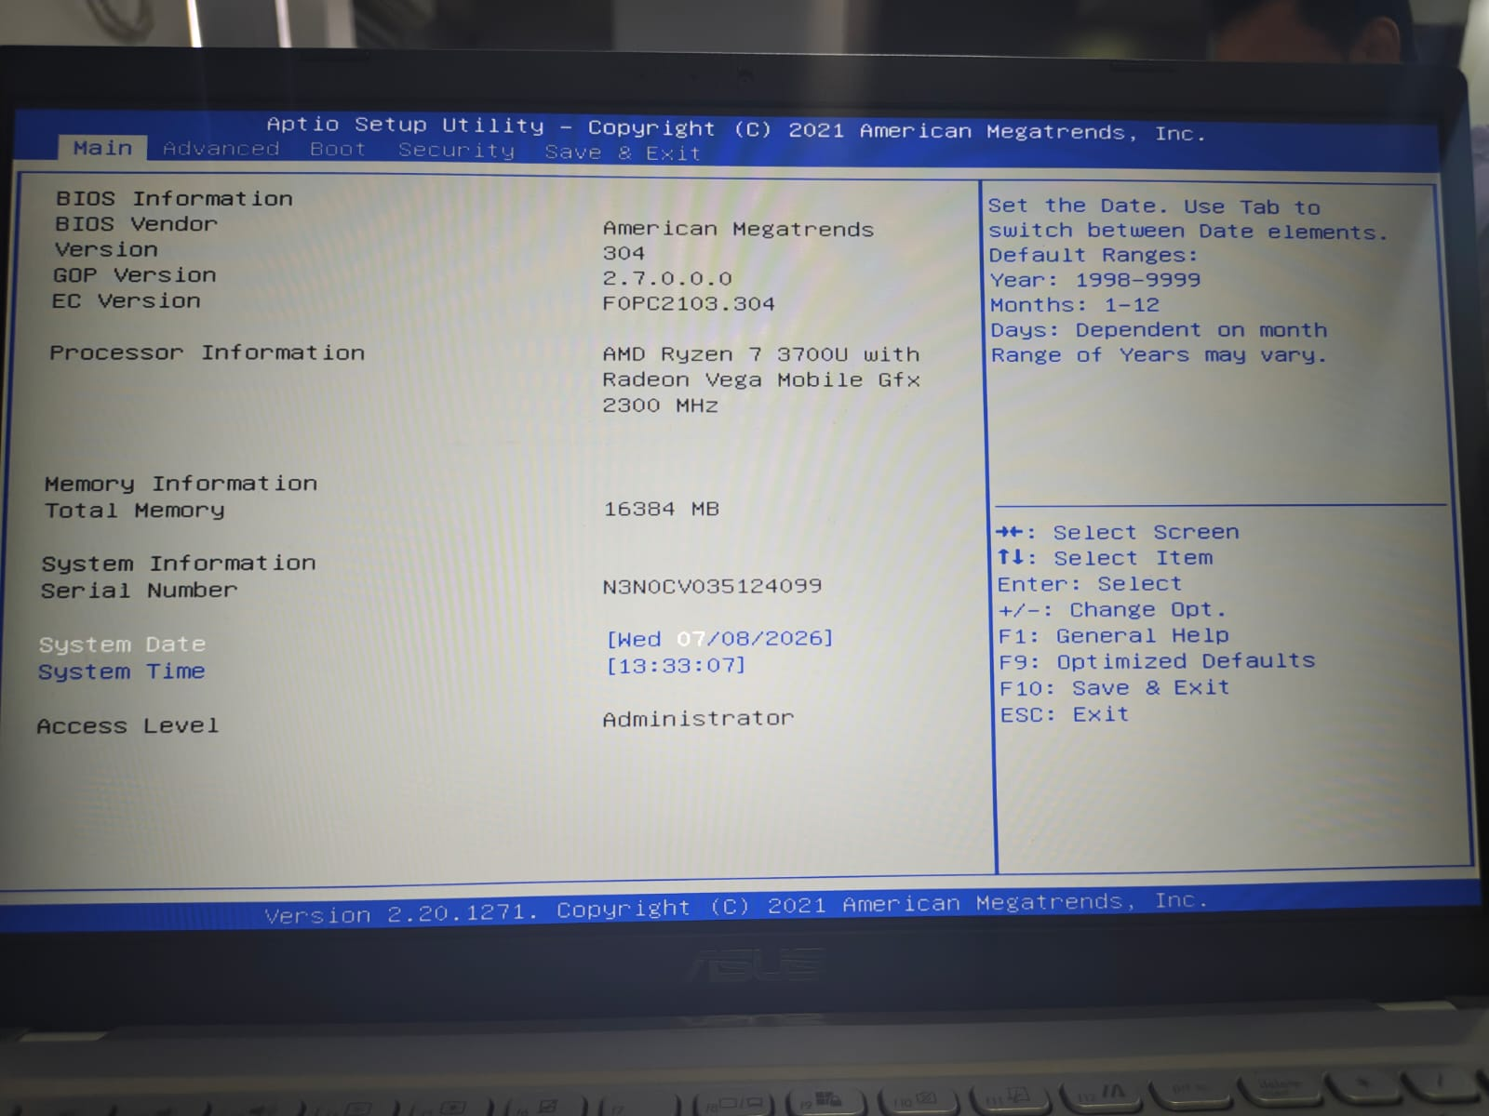
MOTHERBOARD MANUFACTURER:
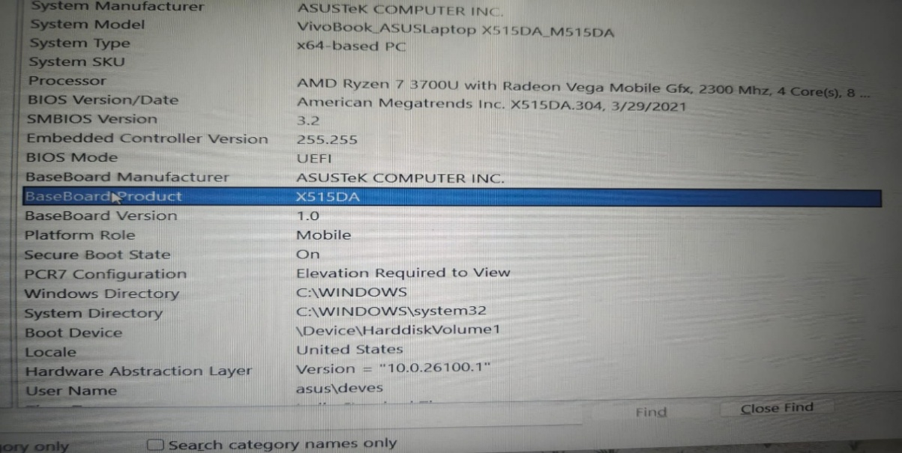

Task 4: CMOS Checksum Error

Error
"CMOS checksum error – Defaults loaded."
Meaning
The CMOS stores BIOS/UEFI configuration information such as system settings and hardware configuration. This message means the stored configuration data does not match the expected checksum, so the BIOS has loaded default settings.
Possible causes
- Weak or dead CMOS battery
- Incorrect BIOS settings
- BIOS settings becoming corrupted
- Recent hardware/configuration changes
Resolution
- Enter BIOS/UEFI setup.
- Check whether the date and time are incorrect.
- Load the appropriate default/optimized settings if necessary.
- Save the settings and restart.
- If the error repeatedly returns, shut down the PC and replace the CMOS battery (usually a CR2032 coin battery) with the correct compatible battery.
- Enter BIOS/UEFI again.
- Set the correct date, time and required configuration.
- Save the changes and restart.
- If the error continues, investigate possible BIOS/firmware or motherboard problems.

